**Sustainable Mobility Tracker**

**By Samanyu B Rao, Smit Vichare, Mrs. S. Kanmani**

1.Student, SRM KTR, R2FR+6GQ, Potheri, SRM Nagar, Kattankulathur, Tamil Nagar, 603203

2.Student, SRM KTR, R2FR+6GQ, Potheri, SRM Nagar, Kattankulathur, Tamil Nagar, 603203

3. Assistant Professor, SRM KTR, R2FR+6GQ, Potheri, SRM Nagar, Kattankulathur, Tamil Nagar, 603203

Author’s Email: [samanyu48@gmail.com](mailto:samanyu48@gmail.com), Co-Author’s Email: [smitvichare@gmail.com](mailto:smitvichare@gmail.com), First Author’s Email: [kanmanis@srmist.edu.in](mailto:kanmanis@srmist.edu.in)

Author’s Contact: +91-9900025186.,Co-Author’s Contact: +91-9922916481, First Author’s Contact: +91-9952097187

**Abstract:** This paper presents a web application developed using the Flask framework for predicting and comparing the fuel consumption and CO2 emissions of various vehicle models. The application leverages machine learning models, including linear regression, ridge regression, lasso regression, and elastic net regression, to estimate fuel consumption and CO2 emissions based on user-provided input features. The models are trained and loaded into the application, allowing users to select a vehicle make and input relevant features for prediction. The system identifies the best-performing model for each prediction, highlighting the closest prediction and its associated error percentage. Additionally, the application offers a comparison feature that enables users to compare specifications of different vehicle models within the dataset. Users can select two vehicle models, and the system retrieves and displays their specifications, facilitating informed decision-making for consumers and researchers interested in understanding the environmental impact of vehicle choices. The web application provides an intuitive interface for exploring fuel consumption and emissions data, making it a valuable tool for both consumers and researchers in the automotive industry.

***Index******terms*:** Flask, Machine Learning, Regression Models, Fuel Consumption, CO2 Emissions, Vehicle Models, Web Application, Comparison, Specification Retrieval.

1. **INTRODUCTION**

This paper introduces a web-based application developed using the Flask framework, aimed at predicting and comparing fuel consumption and CO2 emissions of various vehicle models. As environmental concerns and fuel efficiency become increasingly critical, tools that enable consumers and researchers to make informed decisions about vehicle choices are of paramount importance. Leveraging machine learning models, including linear regression, ridge regression, lasso regression, and elastic net regression, this application provides users with the ability to estimate fuel consumption and CO2 emissions based on user-specified input parameters.

The system not only offers predictive capabilities but also employs a model selection mechanism to identify the best-performing model for each prediction, enhancing prediction accuracy. Additionally, the application provides a comparison feature that allows users to compare specifications of different vehicle models, aiding in the evaluation of eco-friendly options.

In an era where sustainability and eco-consciousness are paramount, this web application serves as a valuable resource for individuals and researchers seeking to explore and understand the environmental impact of various vehicle models.

1. **Architecture Diagram**

This paper introduces an innovative web application designed to enhance the accessibility and analysis of vehicle-related environmental data. The application encompasses a multifaceted approach, comprising six interconnected modules that collectively facilitate the prediction, evaluation, and visualization of fuel consumption and CO2 emissions. These modules cover data collection and preprocessing, integration of machine learning predictive models, model evaluation and selection, enhanced forecasting and mitigation strategies, user-friendly interface development, and graphical representation of fuel consumption trends. The integration of these modules within the application provides users with a comprehensive tool for informed decision-making, enabling a deeper understanding of the environmental impact of their vehicle choices and promoting sustainable transportation practices.

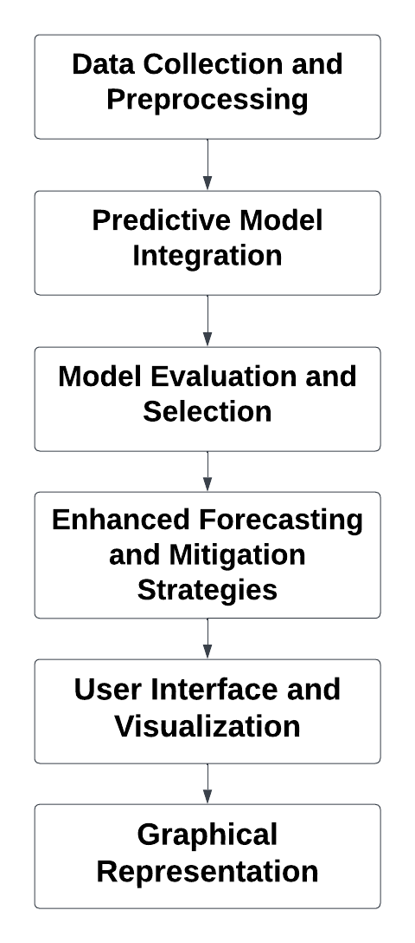

1. **Data Collection and Preprocessing**

This module focuses on the collection and preprocessing of data used in the application. It starts by loading fuel consumption data from a CSV file, organizing it into a structured dictionary, and extracting relevant information such as the make, model, and fuel consumption values. The data is then made available for further analysis and prediction. Data preprocessing steps include handling missing values, organizing data into a suitable format, and ensuring consistency and quality in the dataset. This module plays a critical role in providing clean and structured data for subsequent modeling and analysis.

1. **Predictive Model Integration**

The Predictive Model Integration module incorporates machine learning models into the application. It loads pre-trained models, including linear regression, ridge regression, lasso regression, and elastic net regression, from serialized files. These models are used for predicting fuel consumption and CO2 emissions based on user-provided input features. The integration of these models allows the application to make accurate predictions and provide valuable insights to users. Model integration is essential for leveraging advanced analytics to estimate key environmental factors related to vehicle usage.

1. **Model Evaluation and Selection**

The application evaluates and selects the most appropriate predictive model for a given input. It iterates through the loaded models and calculates predictions for fuel consumption and CO2 emissions. The module then compares these predictions to actual values from the dataset, identifying the model with the closest prediction. Evaluation metrics, such as the error percentage, are calculated to assess the accuracy of predictions. Model selection ensures that the application recommends the most accurate predictive model, enhancing the quality of the provided information to users.

1. **Enhanced Forecasting and Mitigation Strategies**

The predictive capabilities of the application by providing enhanced forecasting and mitigation strategies. It calculates error percentages to quantify the accuracy of predictions and highlights the closest prediction to the actual values. Additionally, it suggests potential mitigation strategies based on the error percentages, helping users make informed decisions to reduce fuel consumption and CO2 emissions. By offering actionable insights and strategies, this module contributes to environmental sustainability and promotes responsible vehicle usage.

1. **User Interface and Visualization**

The User Interface and Visualization module are responsible for creating an interactive and user-friendly interface. It uses Flask, a web framework, to create web pages that allow users to input data, view predictions, and explore various functionalities of the application. Through well-designed templates and forms, users can easily interact with the system, making it accessible to both experts and non-experts. Visualization elements enhance the user experience by presenting data in a clear and informative manner, facilitating data-driven decision-making.

1. **Graphical Representation**

The Graphical Representation module offers visualizations and graphical representations of fuel consumption data. It allows users to select specific vehicle makes and view line plots illustrating fuel consumption trends for different models within the selected make. This module enhances data exploration and comprehension, enabling users to identify patterns and variations in fuel consumption across different vehicle models. Visualizations play a crucial role in conveying insights effectively, aiding users in understanding and analyzing the environmental impact of vehicle choices.

1. **Future Work**

Future work may involve expanding the dataset to include more vehicle attributes and exploring other advanced machine learning techniques for enhanced prediction accuracy.

**RESULT**

In conclusion, the developed web application demonstrates a holistic approach to addressing crucial aspects of vehicle fuel consumption and CO2 emissions analysis. It efficiently collects and preprocesses data, integrates predictive models, evaluates model performance, and offers enhanced forecasting and mitigation insights. The user-friendly interface and visualizations empower users to make informed decisions related to vehicle selection and environmental impact. By bridging the gap between data-driven analysis and user engagement, this application contributes to promoting eco-friendly vehicle choices and serves as a valuable tool for consumers and researchers interested in reducing fuel consumption and mitigating the environmental footprint of the automotive industry.

**Fig 1: Home Page**

**Fig 2: Main Feature - Input Parameters are given and the predictions are done.**

**Fig 3: The graph for a particular company and all its models**

**Fig 4: A Sub feature - Comparison between different models with respect to their features**

**REFERENCES**

[1] Global Energy Review 2020

[2] Ağbulut, Ü. Forecasting of transportation-related energy demand and CO2 emissions in Turkey with different machine learning algorithms. Sustain. Prod. Consum. 2022, 29, 141–157.

[3] Qian, Y.; Sun, L.; Qiu, Q.; Tang, L.; Shang, X.; Lu, C. Analysis of CO2 drivers and emissions forecast in a typical industry-oriented county: Changxing County, China. Energies 2020, 13, 1212.

[4] Safa, M.; Nejat, M.; Nuthall, P.L.; Greig, B.J. Predicting CO2 Emissions from Farm Inputs in Wheat Production using Artificial Neural Networks and Linear Regression Models. Int. J. Adv. Comput. Sci. Appl. 2016, 7, 268–274

[5] Ahmadi, M.H.; Jashnani, H.; Chau, K.W.; Kumar, R.; Rosen, M.A. Carbon dioxide emissions prediction of five Middle Eastern countries using artificial neural networks. Energy Sources Part Recover. Util. Environ. Eff. 2019, 1–13

[6] Saleh, C.; Dzakiyullah, N.R.; Nugroho, J.B. Carbon dioxide emission prediction using support vector machine. IOP Conf. Ser. Mater. Sci. Eng. 2016, 114, 012148.